**Aim:** Create a simple cloud software application for Car Booking Reservation System using any Cloud Service Provider to demonstrate SaaS include the necessary fields such as search for cabs, from, to, rental , out station, Package type, hours/Days etc.

**Step 1:** Create application ‘Car 24/7’, create ‘location’ and add information.

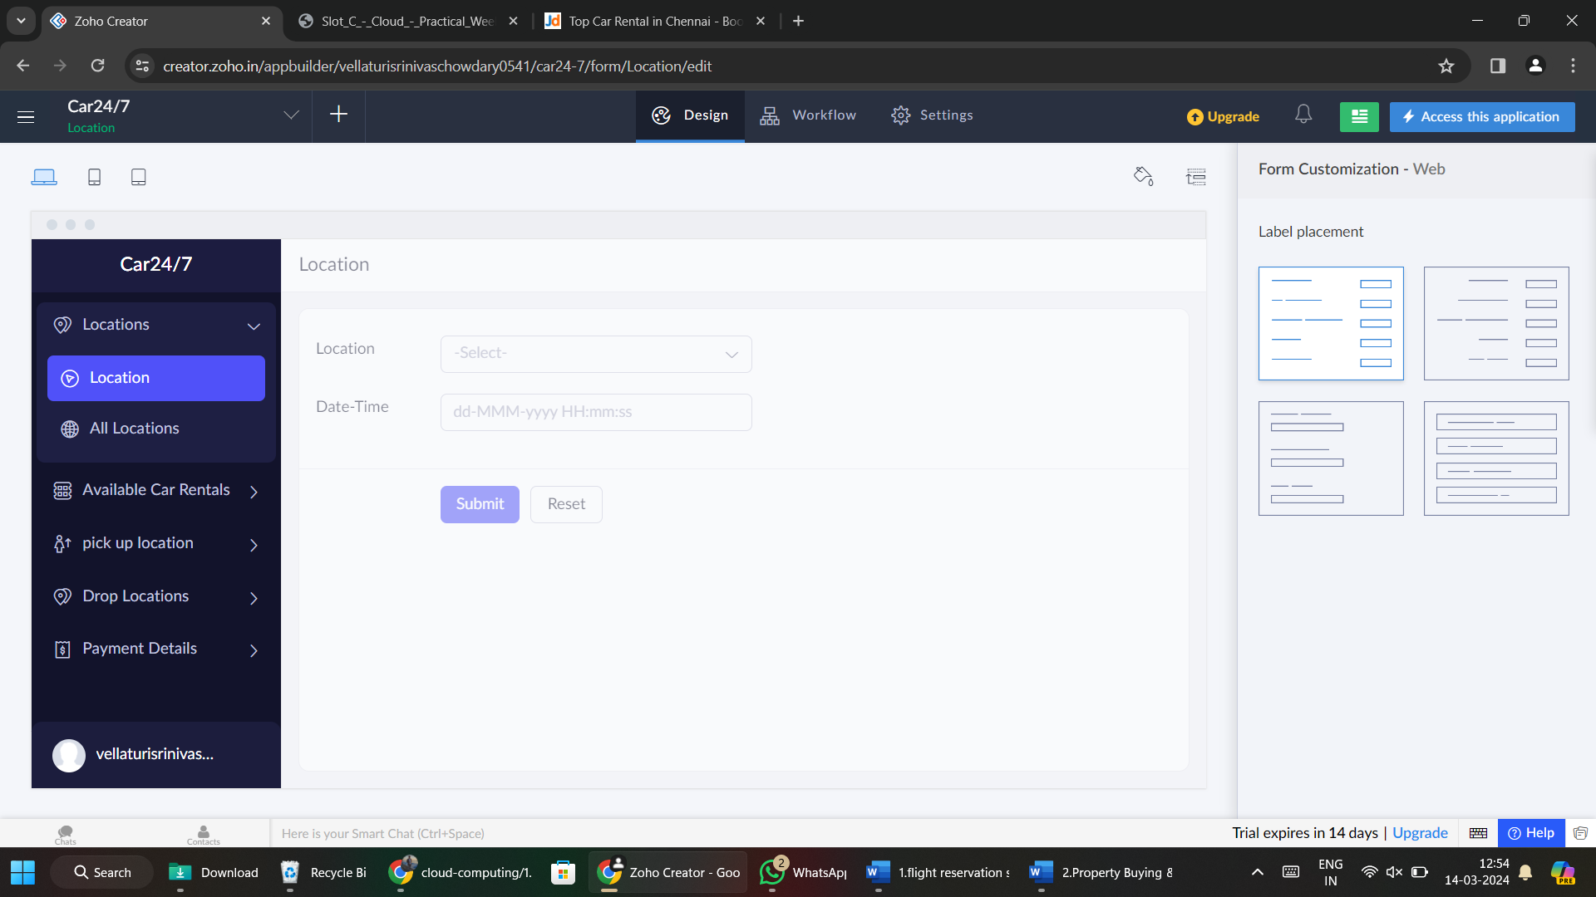

**Step 2:** Create ‘Available Car Rentals’ and add information.

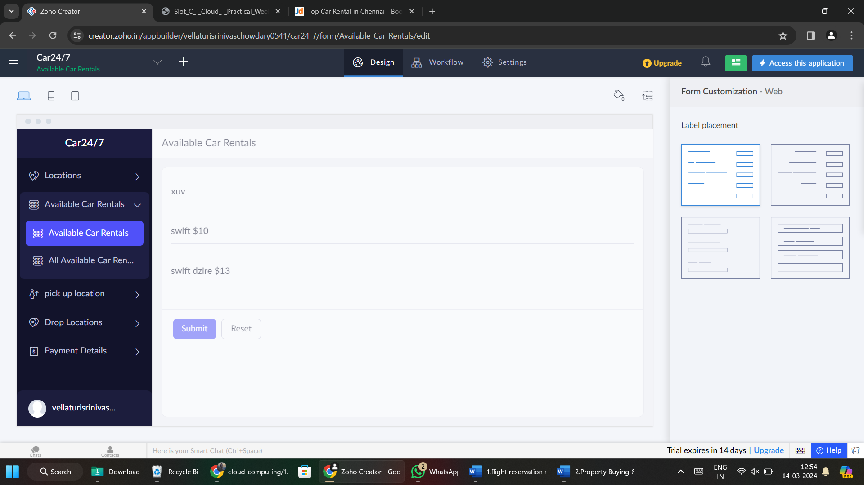

**Step 3:** Create ‘Pick Up Location’ and add information.

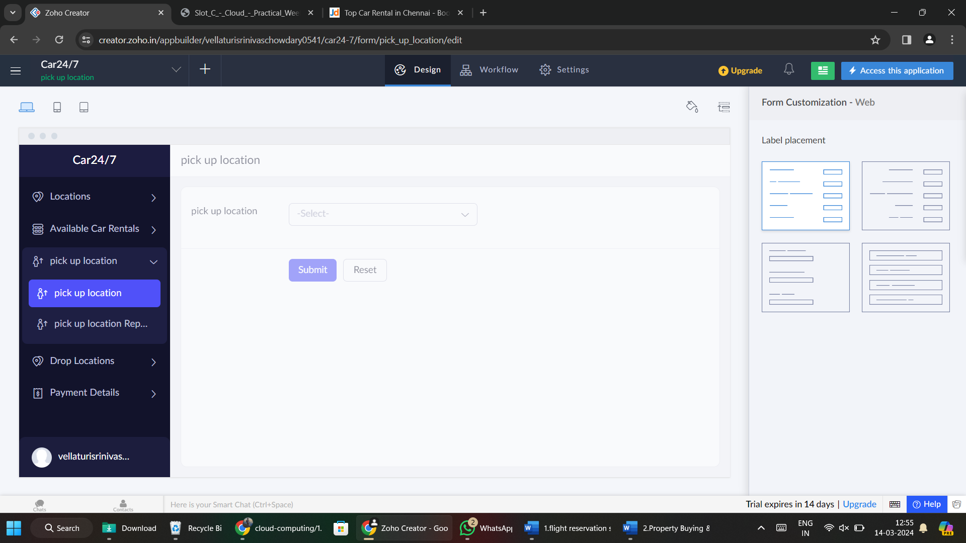

**Step 4:** Create ‘Drop Location’ and add information.

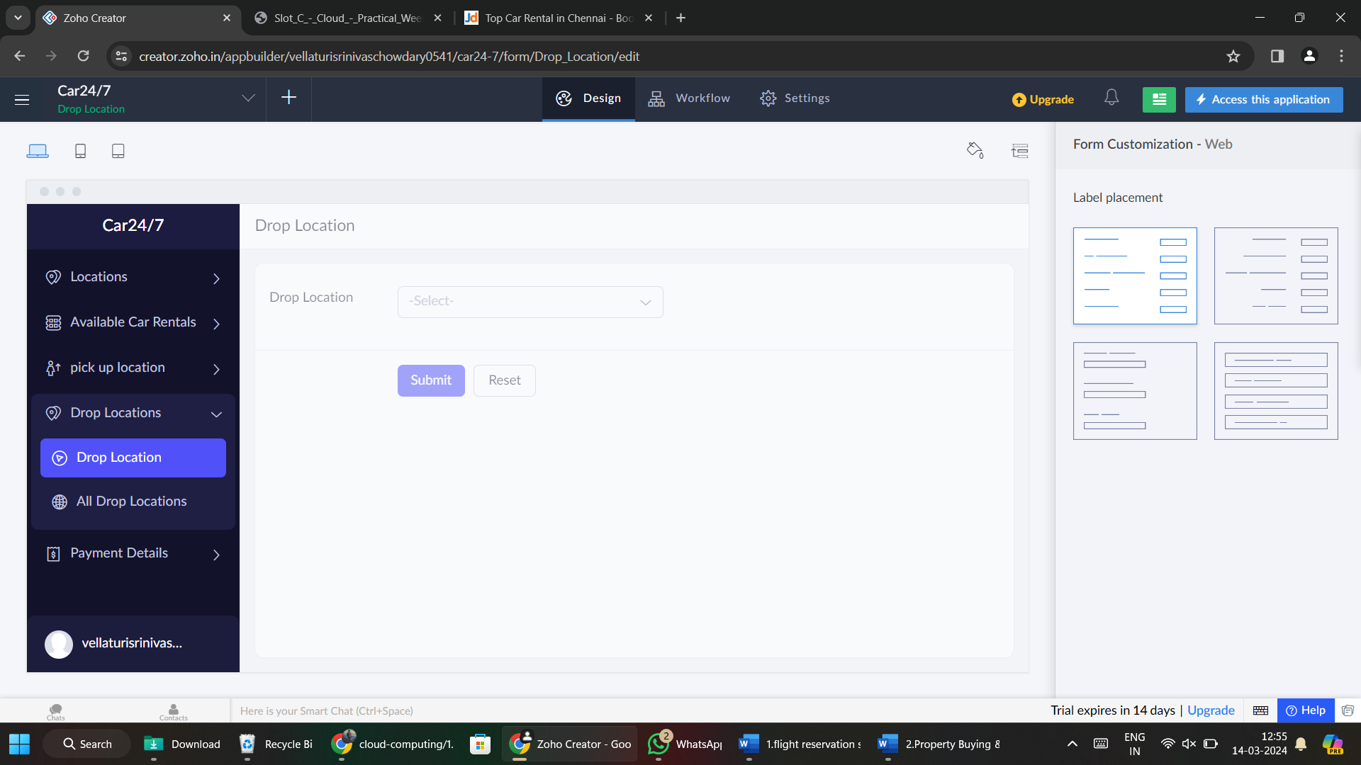

**Step 5:** Create ‘Payment Details’ and add information.

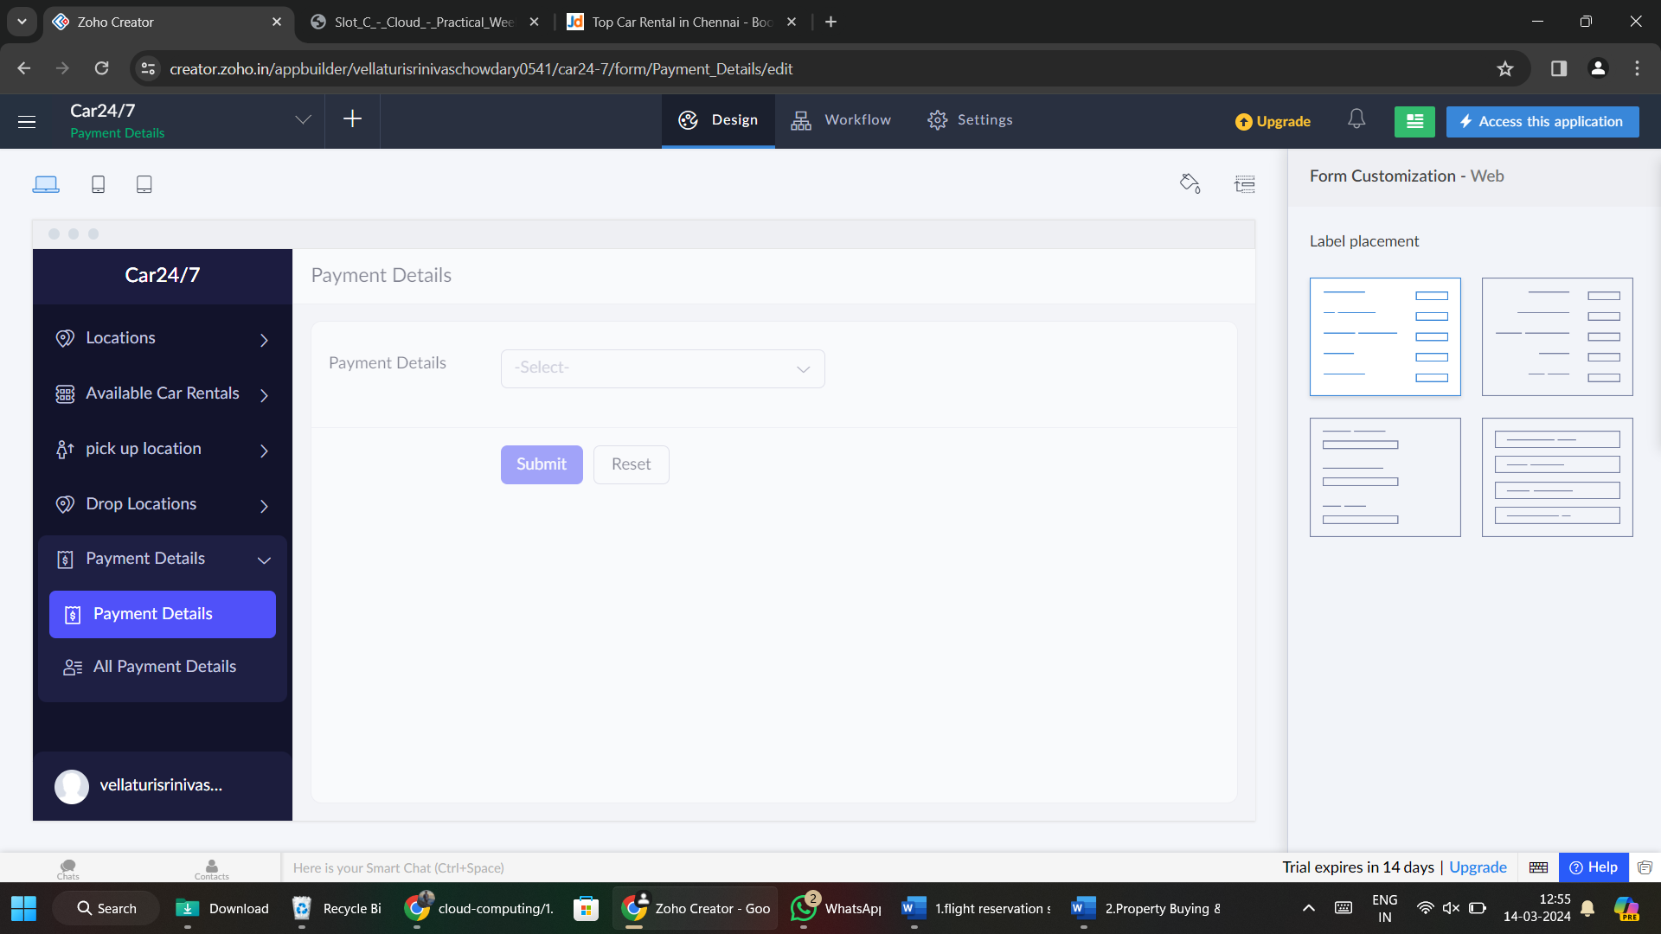

**Step 6:** Fill the details.

